REPORT ON CERTIFICATE COURSE ON INSOLVENCY AND BANKRUPTCY CODE, 2016
organized BY
DEPARTMENT OF LAW,
DR. AMBEDKAR COLLEGE, DEEKSHABHOOMI, NAGPUR
IN COLLABORATION WITH RTMNU’S DEPT. OF LIFELONG LEARNING AND EXTENSIONS

11TH NOVEMBER 2021 TO 25TH November

Name of Add on/Certificate programs offered | Year of offering | No. of times offered during the same year | Duration of course | Number of students enrolled in the year | Number of Students completing the COURSE IN the year
CERTIFICATE COURSE ON INSOLVENCY AND BANKRUPTCY CODE, 2016 | 2021 | one | 11TH NOVEMBER 2021 TO 25TH November | 25 | 25

ORGANISING COMMITTEE

DR. H.V. MENON  PROFESSOR AND HEAD,  DEPARTMENT LAW,  DR. AMBEDKAR COLLEGE,  DEEKSHABHOOMI, NAGPUR | COMMITTTE CHAIR
DR. PRATIMA LOKHANDE  ASSOCIATE PROFESSOR  DEPARTMENT OF LAW,  DR. AMBEDKAR COLLEGE,  DEEKSHABHOOMI, NAGPUR | COURSE DIRECTOR
ANUSHA PATRE  ASSISTANT PROFESSOR  DEPARTMENT OF LAW,  DR. AMBEDKAR COLLEGE,  DEEKSHABHOOMI, NAGPUR | COURSE CO-ORDINATOR

BACKGROUND

The situation of companies being liquidated due to running into losses is extremely common in India at present. The total amount of dud loans of the banks, called non-performing assets in banking terminology, threatened to destabilize the entire banking system of India. This forced the government to introduce very advanced legislation for insolvency and bankruptcy in India.This is where insolvency experts step in. Using the new law, they figure out if the business is doomed or if it can be taken over by a competitor with more funds and then run more efficiently. They may even sell off the machinery or intellectual property, unsold stocks and other assets of the company to raise as much money as possible to pay the creditors.The insolvency and bankruptcy code are a huge step. It has changed the economic math in India. It is expected to make the Indian economy efficient, and keep creditors in check.

INTRODUCTION

Dept. Of Law, Dr. Ambedkar college, Deekshabhoomi, Nagpur launced under its flagship a certificate course on 11th November 2021 on Insolvency and bankruptcy code, 2016 in collaboration with RTMNU’s Dept of Lifelong Learning and Extension.
A unique objective of this course is to juxtapose the legal principles and propositions within the realm of entrepreneurship and to develop a cumulative and comprehensive understanding of insolvency laws in the context of entrepreneurship. Adiscussions by our academia panel about their experience in IBC, Live drafting of applications to be filed before the NCLT, Complete and step by step coverage of Corporate Insolvency Resolution & Liquidation process, and Bankruptcy proceedings, Additional readings on the latest developments in the market and concepts, amendments, case laws and ongoing controversies, Simulation exercises on different aspects of the mechanism of Insolvency and Bankruptcy Code .

COURSE HIGHLIGHTS

- course duration : 30 hours – 15 days
- batch size : 25
- eligibility criteria : law students, CS/CA/CMA students, Lawyers, bankers, research scholors, academicians, working professionals.
- course type : online through google meet
- course fee : rs. 2000/-

AGENDA OF THE INAUGURAL SESSION - 11.11.2021

SR. NO | TIME | ACTIVITY | SPEAKER
1 | 4.00 PM – 4.10 PM | INTRODUCTION BY THE COURSE CO-ORDINATOR | MS. ANUSHA PATRE
2. | 4.10 PM – 4.20 PM | INAUGURATION OF THE CERTIFICATE COURSE | DR. MRS. H.V. MENON
3. | 4.20 PM - 4.30 PM | INTRODUCTORY REMARKS FOR THE CERTIFICATE COURSE | DR. MS. PRATIMA LOKHANDE
4. | 4.30 PM – 6.00 PM | ADDRESS BY THE CHIEF GUEST AND FIRST SESSION | CA CS PAVAN GAHUKAR

INAUGURAL SESSION OF THE INSOLVENCY AND BANKRUPTCY CODE,2016

Department of Law, Dr. Ambedkar college, Deekshabhoomi, Nagpur organized A !5 days online certificate course on INSOLVENCY AND BANKRUPTCY CODE,2016 under RTMNU’s Department of Lifelong Learning and Extension on 11th November 2021. CA CS Pavan Gahukar was the chief guest of the inaugural session. The Inaugural session was conducted by Anusha Patre, assistant professor and course co-ordinator. She introduced the course highlighting the importance of Insolvency and Bankruptcy Code, 2016.

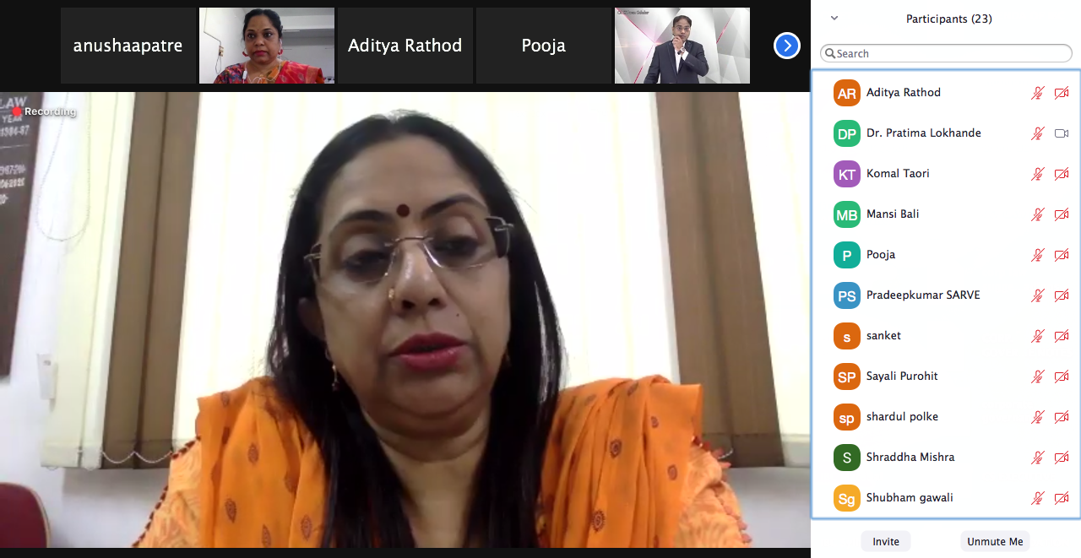

the session continued with the inaugural of the certificate course by Professor and Head of the Dept., Dr. H.V.Menon. She briefed about the initiative taken by the Dept. concluded wishing success to the participants.

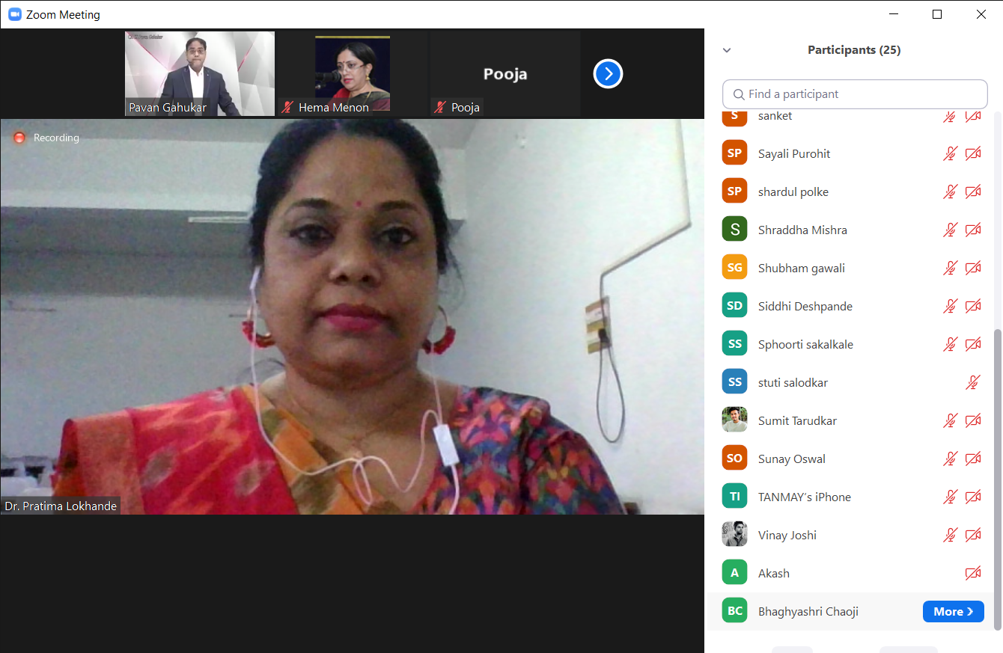

introductory remarks on the course was delivered by the Director and Assistant Professor, Dr. Pratima Lokhande.
She was the brain behind this course and she mentioned that this course will enable students in initiating the corporate resolution process as well as help in the filing of
insolvency applications before the National Company Law Tribunal. This course is a practical guide for those preparing for the IBC practitioner exam
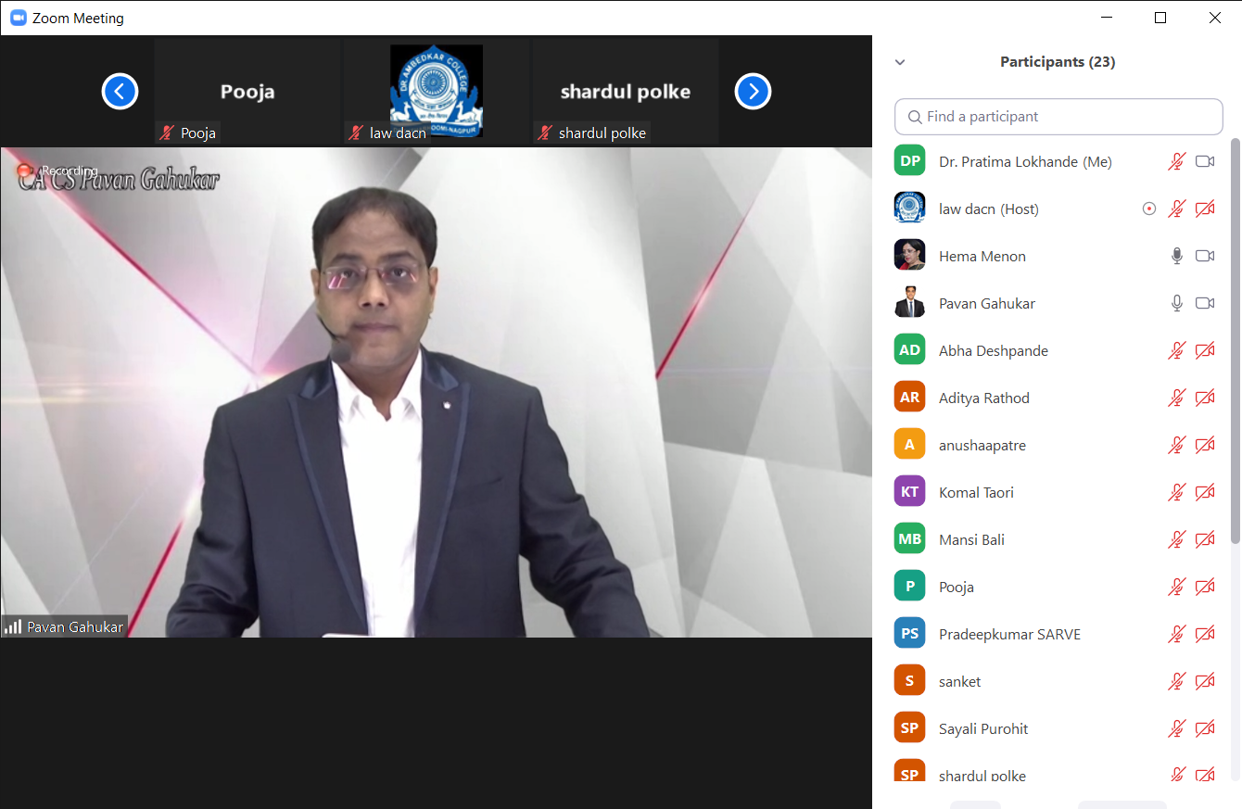
the ceremony continued with the address by the Chief Guest of the Inaugural Session CA CS Pavan Gahukar. Pavan Sir also conducted the First lecture on 11.11.2021 and Second lecture on 12.11.2021 of the Course. In his highly Interactive session he focused on the Historical background, the Need and Key concepts of IBC. He Kept the participants engaged by Conducting an enthralling Quiz on IBC.

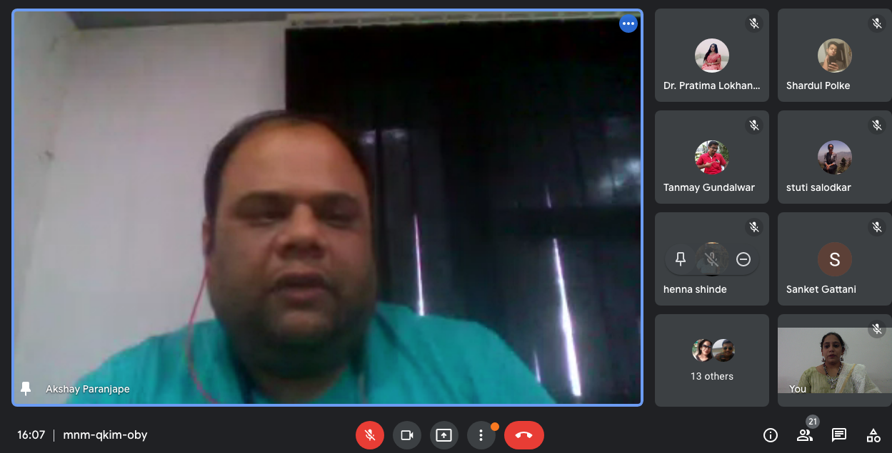

The second unit was taken by CS Akshay Paranjape on 13.11.2021 and 14.11.2021. Being a practising CS he eludicated on the corporate insolvency Resolution process highlighting the legal provisions, procedure, documentation and the recent cases of ______ in the regime of Insolvency and Bankruptcy Code.

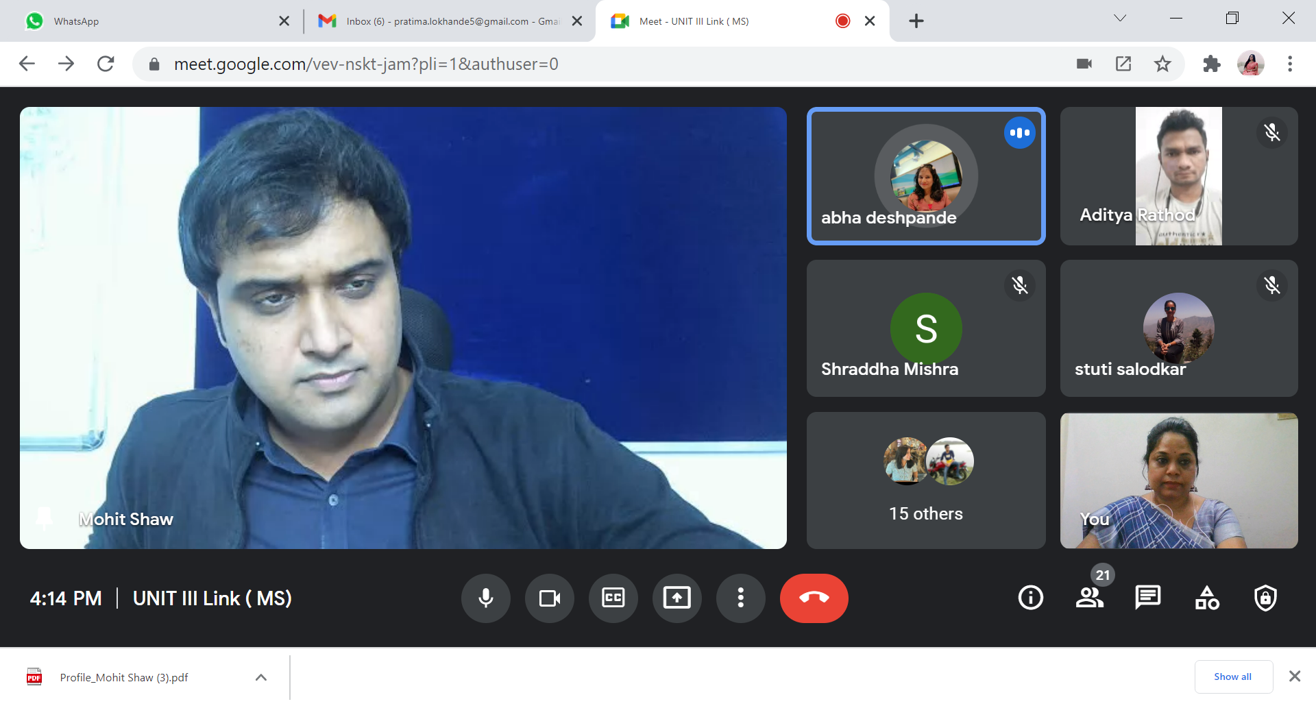
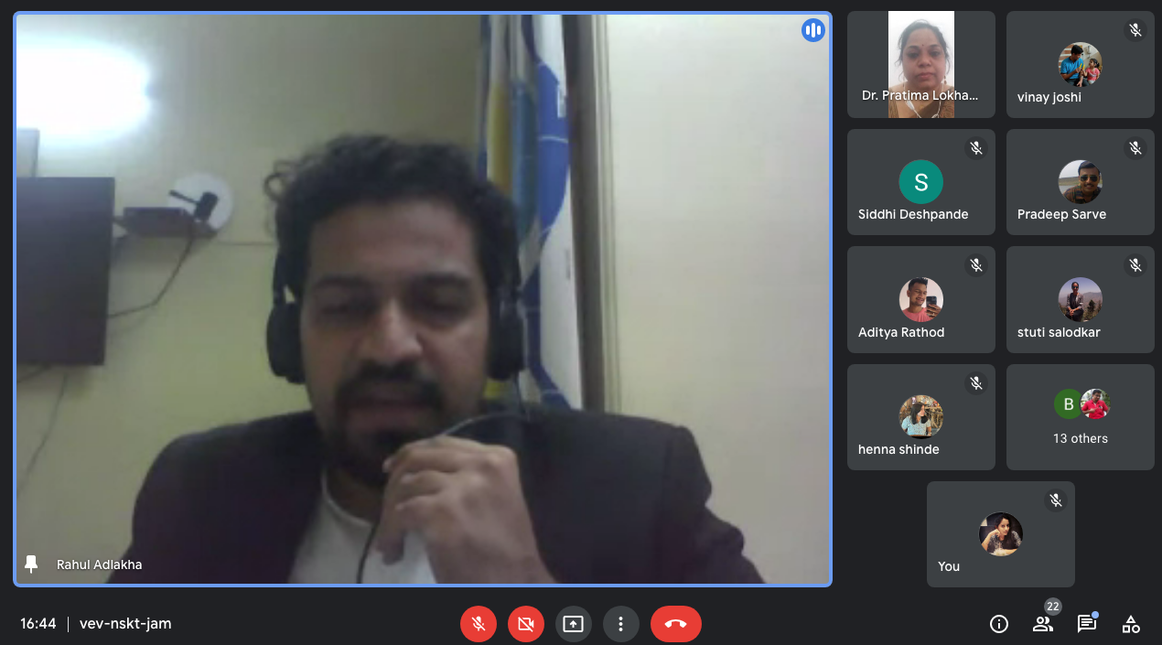

CS Mohit Shaw (17.11.2021) and Adv. Rahul Adlakha (18.11.2021) discussed the third unit with the participants. they centered there area of discussion around the adjudicating authorities, appellate authorities, resolution professionals –their role, functions and duties and the role of Insolvency and Bankruptcy Board of India.

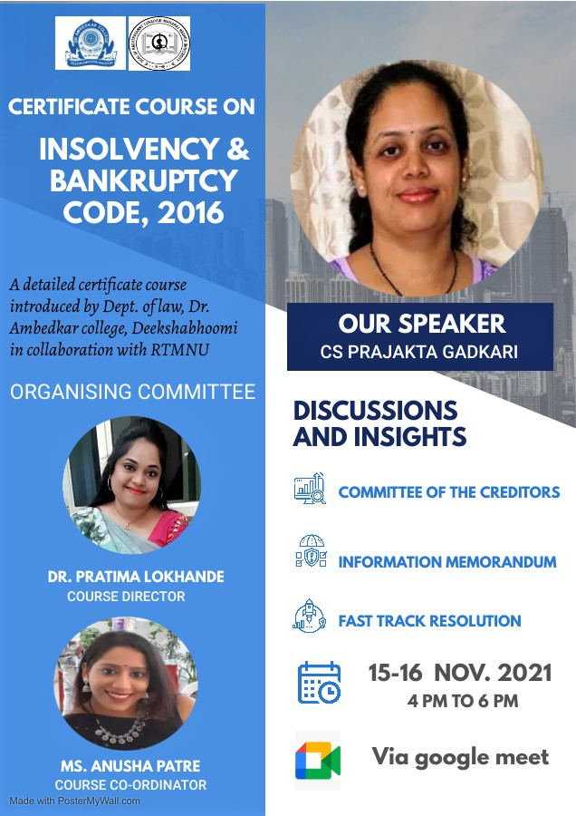
On 15.11.2021 and 16.11.2021, CS Prajakta Gadkari continued the session with the participants, enlightening them about the committee of creditors, the information memorandum and fast track resolution plan.

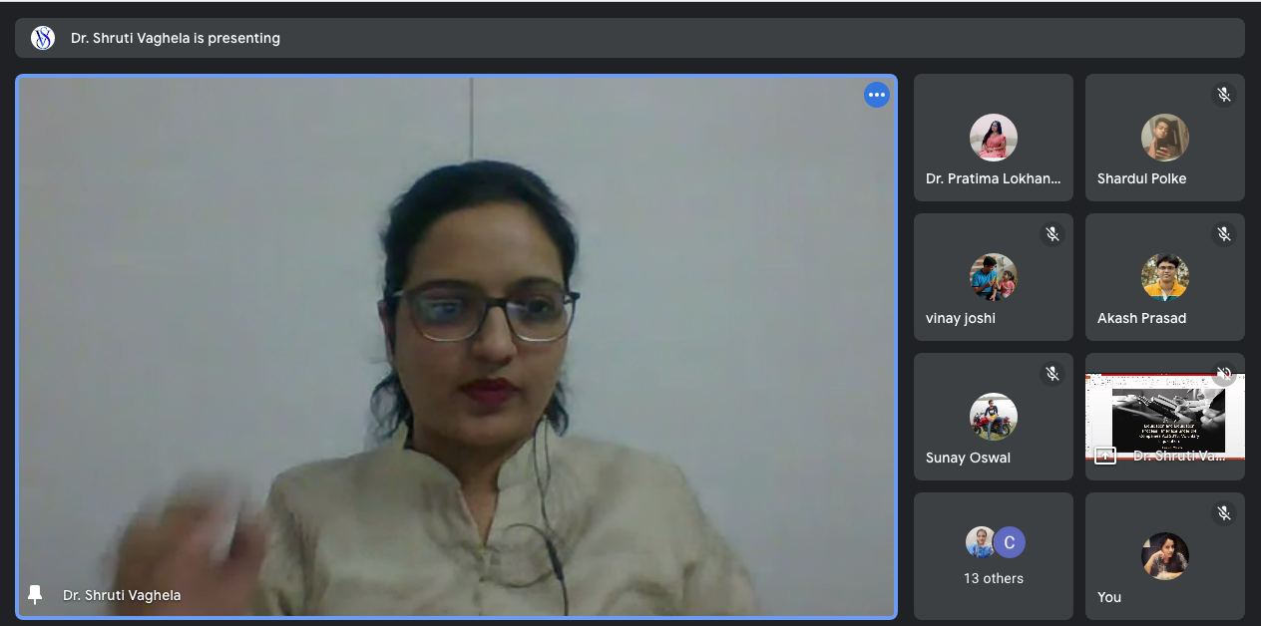

we had Dr. Shruti Vaghela for the Fifth Unit of the course. on 19.11.2021 and 20.11.2021. she discussed the step by step Liquidation Process and its Interface under the Companies Act 2013. she also eludicated about the Voluntary Liquidation and it process.

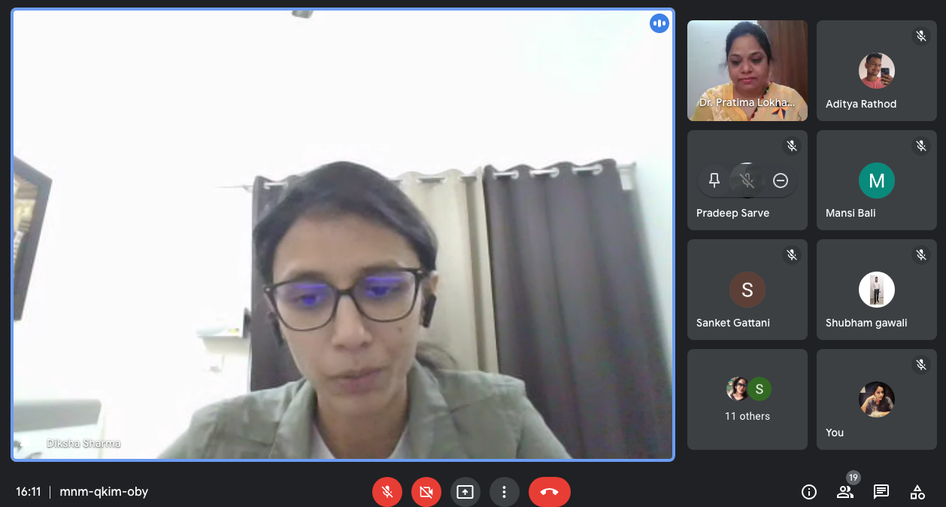

CA Diksha Sharma was a one day speaker on 21.11.2021. she guided the participants on the international topic of Cross Border Insolvency and the International Perspective,
Global Developments for IBC.

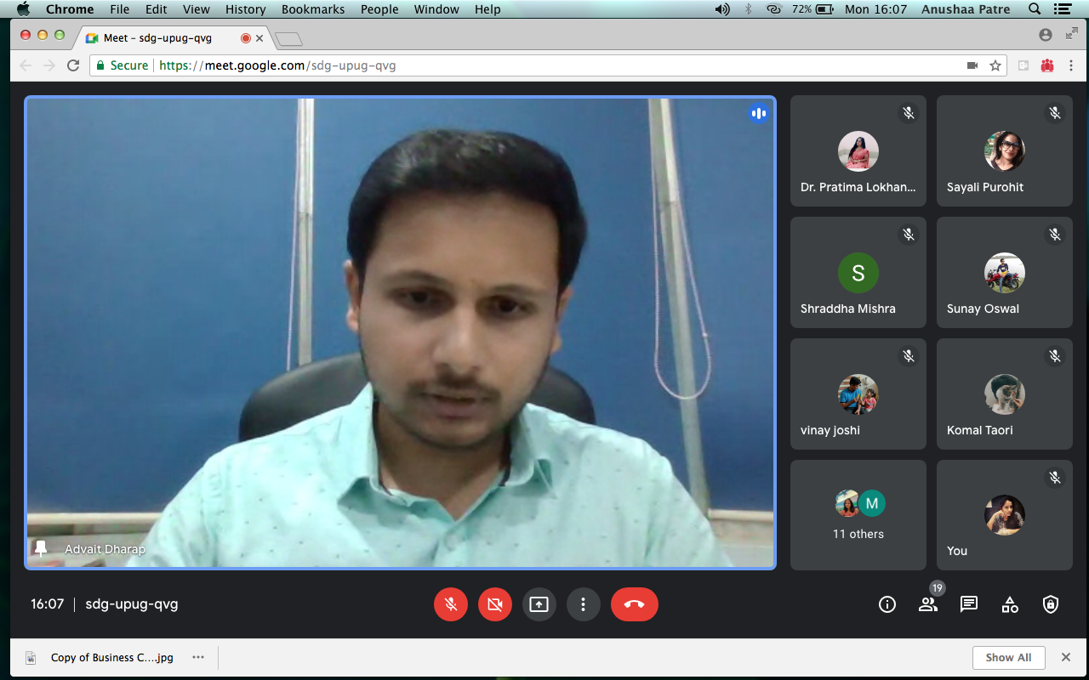
CA Advait Dharap on 22.11.2021 provided knowledge about the newly added provisions of pre packed insolvency and the pitfalls of the code since its inception and how standing committee can overcome them.

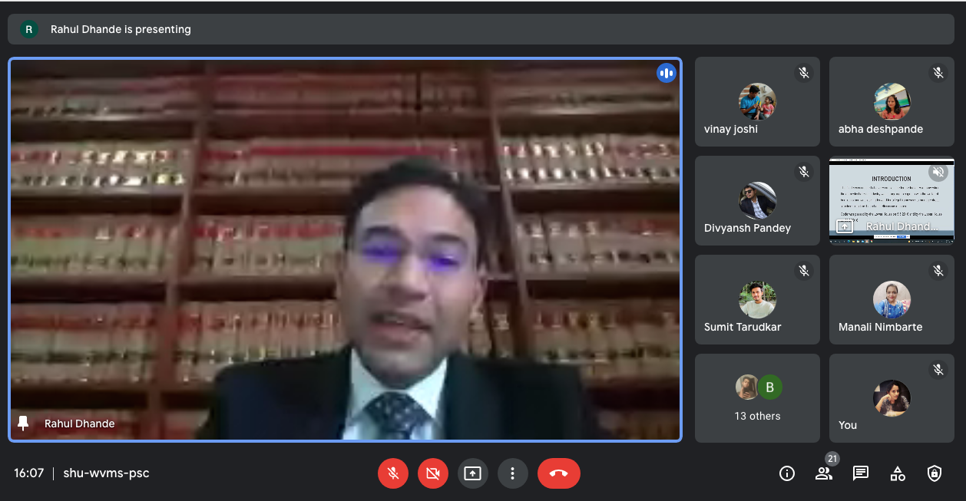
the second last unit was taken by Adv. Rahul Dhande on 23.11.2021 and 24.11.2021 wherein he addressed the participants about the Offences and Penalties in the code and took live drafting session of application/petition under the IBC Code
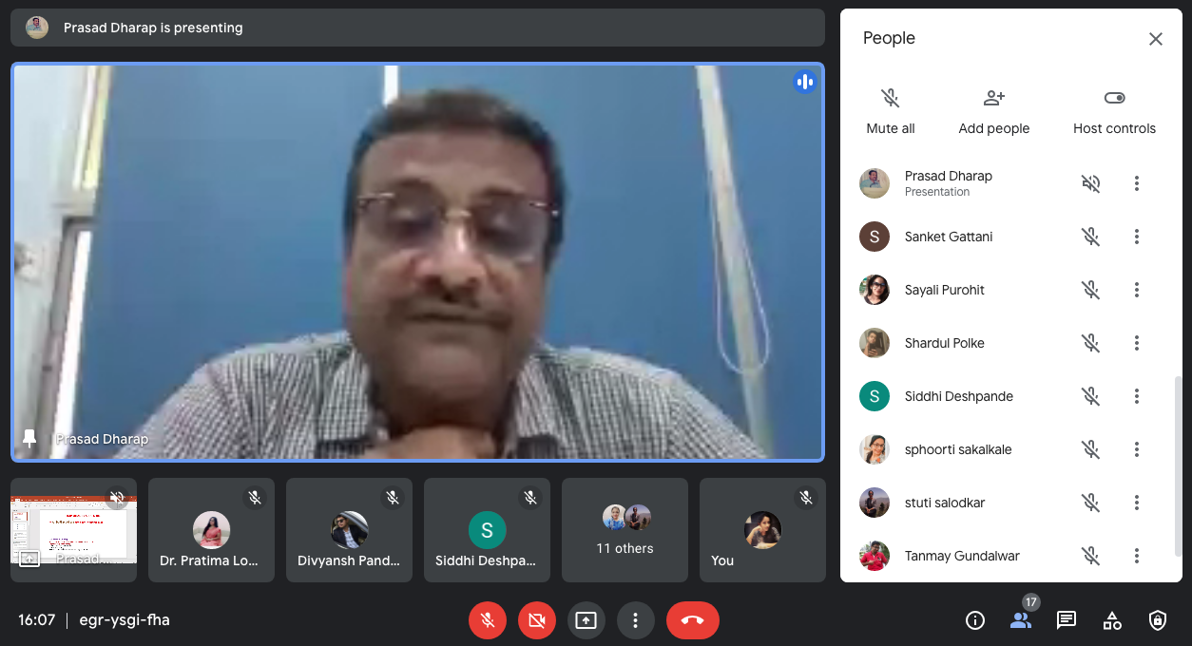

CA Prasad Dharap took the last session of the certificate course on 25.11.2021 highlighting the important cases and decisions taken under IBC, 2016.

AGENDA OF THE VALEDICTORY SESSION ON IBC, 2016 ON 25.11.2021

SR. NO | ACTIVITY | SPEAKER
1 | CONDUCT OF VALEDICTORY SESSION | MS. ANUSHA PATRE
2. | PRINCIPAL’S ADDRESS | DR. B.A. MEHERE
3. | VALEDICTORY REPORT | MS. ANUSHA PATRE
4. | RESOURCE PERSON VIEWS | CA CS PAVAN GAHUKAR  CS PRAJAKTA GADKARI
5. | FEEDBACK BY PARTICIPANTS
6. | VALEDICTORY ADDRESS BY CHIEF GUEST | CA PRASAD DHARAP
7. | VOTE OF THANKS | DR. PRATIMA LOKHANDE

Valedictory session of the Insolvency and Bankruptcy
Code,2016

The last day of the certificate course session was conducted by Ms. Anusha Patre and was commenced with a welcoming session. It was immediately followed by the principal’s address. In her address she emphasized that with the intellectual content of the syllabus, inquisitiveness in the teaching by different speakers was maintained and it was an enriching learning process for all the participants. Chief Guest CA PRASAD DHARAP in his address stated that he is quite sure that this course must have been a stimulating and invigorating experience for all the participants. Dr. Pratima Lokhande Sincerely Acknowledged every One for Joining Valedictory Session of Certificate Course on IBC In Collaboration With RTMNU. She also thanked all the Guest speakers for their insightful and enlightening teaching. She congratulated all the participants for successfully completing the Certificate Course.

